Reading at Kirkby Avenue Primary School: Our Book Bands

At Kirkby Avenue Primary School we have a book band scheme that we carefully match to children's ages. Many of our books are from the Oxford Reading Tree scheme, however, we compliment this with many other books at the appropriate level so that the children's interest in reading is maintained. You can see from the chart below how the book band and Oxford Reading Tree bands relate to our school scheme.

Kirkby Avenue Book Scheme | Book Band | ORT Book Band
Pink | Band 0 Lilac | ORT 1
Pink/Yellow | Band 1 Pink | ORT 1 +
Yellow | Band 2 Red | ORT 2
Light Blue | Band 3 Yellow | ORT 3
Red | Band 4 Blue | ORT 4
Green | Band 5 Green | ORT 5
Orange | Band 6 Orange | ORT 6
Black | Band 7 Turquoise | ORT 7
Purple | Band 8 Purple | ORT 8
Gold | Band 9 Gold | ORT 9
White | Band 10 White | ORT 10
White | Band 11 Lime | ORT 11
White | Band 12 Brown | ORT 12
Burgundy | Band 13 Grey | ORT 13 and 14
Cream | Band 14 Dark Blue | ORT 15 and 16
Dark Blue | Band 15 Dark Red | ORT 17 and 18
Dark Green | Band 16 Dark Red + | ORT 19 and 20

Throughout school we are continuing to listen to children regularly and we ask, where possible, to maintain this at home in the form of magazines, books, comics, poems and through online materials - see below.

You will need to open the webpage - https://www.oxfordowl.co.uk/

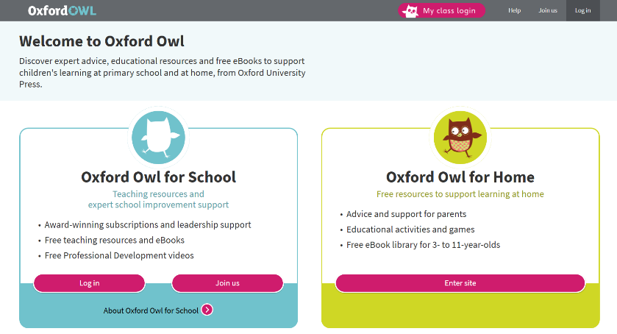
Click on the class log in page and put your classes’ details

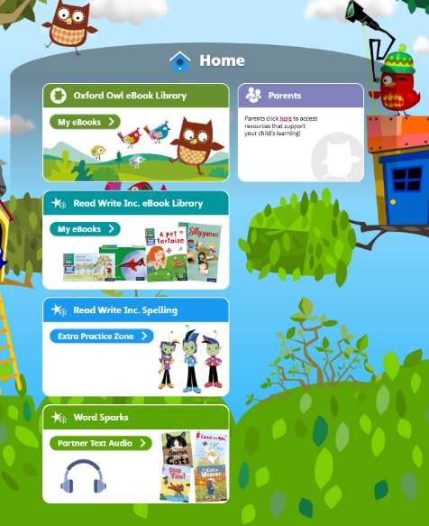

After you have click log on it will load up this page which means you will be able to access reading books and spelling activities.

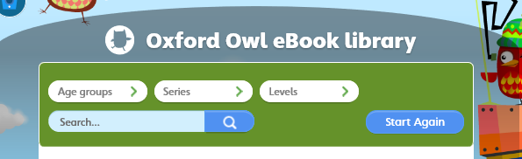

Click on the Green Oxford Owl eBook library and at the top you will be able to search for the books given to you by the class teacher or click on the levels to research your child’s class level.

