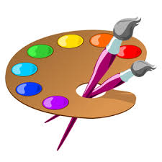
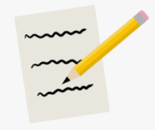
The Stone Age!
As historians, we will be learning all about the chronology of The Stone Age, as well as similarities and difference to how we live today, and we will use artefacts to learn how they lived in that time; focusing on their art form of cave paintings, and finally how this period in history has changed our lives today. We will be developing a multitude of historical skills, using timelines, archaeologist artefacts and different sources of information to back up our opinions.
This half term, we will be having an art focus, linked all to our fabulous topic! Exploring cave paintings, we will be using chalk and imitating the designs created by our ancient ancestors all those years ago!

In Literacy, we will be looking at a range of interesting genres from setting and character descriptions, to poetry and instructions! We can’t wait to sink our teeth into some new books and dive right in!

Welcome back! We hope you have had an amazing Summer holiday and we can’t wait to have a fabulous start to the year! For the Autumn term, our new and exciting topic is
‘The Stone Age!’

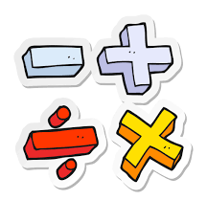
During the Autumn term in Mathematics, we will be learning all about place value and expanding upon our learning from last year! We will also be looking at the 4 operations!
We can’t wait to also read many more ‘Maths Through Stories’ books and link these to our learning!
We will also include other foundation subjects during this term, including: RE, French, Music and PE, giving children a wide and interesting variety of subjects to thrive in.

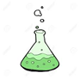
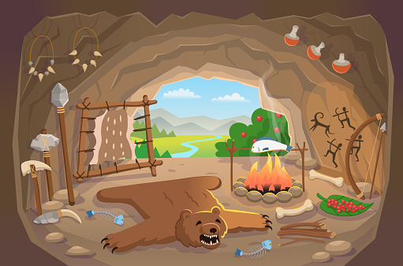
In Science, we will be learning all animals including humans, exploring the different types of skeletons and the rolls our skeletons and muscles play within our body! I wonder what would happen to use without such things? Could we survive?
We will also be doing tons of working scientifically and carry out practical, fun experiments, reporting upon our findings!

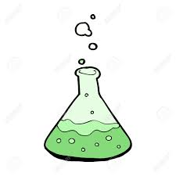
In Science,

