


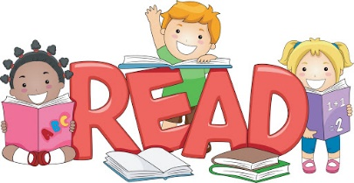

Bring reading to life
You could try cooking a recipe you’ve read together. Would you recommend it to a friend? Alternatively, play a game where you pretend to be the characters in a book, or discuss an interesting article you’ve read.

Create a comfortable space

Make a calm, comfortable place for your family to relax and read independently - or together.

Talk about books
This is a great way to create connections, develop understanding and make reading even more enjoyable. Start by discussing the front cover and talking about what it reveals and suggests the book could be about. Then talk about what you’ve been reading and share ideas. You could discuss something that happened that surprised you, or something new that you found out.

Encourage reading choice

Give children lots of opportunities to read different things in their own time - it doesn’t just have to be books. There’s fiction, non-fiction, poetry, comics, magazines, recipes and much more. Try leaving interesting reading material in different places around the home and see who picks it up.

Read together
Choose a favourite time to read together as a family and enjoy it. This might be everyone reading the same book together, reading different things at the same time, or getting your children to read to each other. This time spent reading together can be relaxing for all.

Make use of your local library
Libraries offer brilliant online materials, including audiobooks and eBooks to borrow.
See www.librariesconnected.org.uk for more information on digital library services and resources.

Encourage your child to read
Reading helps your child’s wellbeing, develops imagination and has educational benefits too. Just a few minutes a day can have a big impact on children of all ages.

Read aloud regularly
Try to read to your child every day. It’s a special time to snuggle up and enjoy a story. Stories matter and children love re-reading them and poring over the pictures. Try adding funny voices to bring characters to life.

