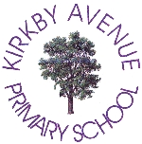  Kirkby Avenue Primary School | Tel: 01302 782953
Kirkby Avenue | admin@kirkbyavenueschool.co.uk
Bentley Road
Doncaster | Head Teacher
DN5 9TF | Mrs C Clifford

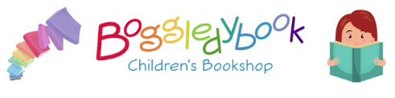

Dear Parents and Carers

Following the positive feedback and huge success of our Boggledybook Book Fair in June, where we sold 441 books!, we are hosting another one on Thursday 24th October – all books are new and priced at £1, £2 or £3 each! There will be a wide range of fantastic books to choose from including picture books, activity books, chapter books and non-fiction. This is Boggledybooks second visit to our school and we are looking forward to welcoming them back.

There are 3 ways to buy so hopefully there is an option to suit all:

- Each class will visit the Book Fair during the day with their teacher – if you wish your child to buy a book during the school day, please send them with the correct money (in a named envelope please).

- Parents can visit the Book Fair after school, up until 4.15pm and choose a book with their child.

- If you prefer to order online you can place an order on their website choosing the ‘Click and Collect’ option, adding a note on the checkout page with your school name, child’s name and class:
www.boggledybook.co.uk/onlineshop

A free book will be donated to school for every 10 collectively sold!

Thank you in anticipation of your support.

Yours Sincerely,
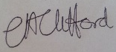

Mrs Clifford
Head Teacher

