

KIRKBY AVENUE PRIMARY SCHOOL REMOTE LEARNING OFFER
Lockdown or Whole bubble isolation:
- Use of Zoom/Teams for live and recorded lessons
- Use of Teams and Class Dojo remote platforms for setting daily tasks and activities and giving feedback (three hours daily learning for Foundation/Key Stage 1 and four hours daily learning for Key Stage 2)
- Communication with parents to ascertain what IT/Internet devices they have and whether they need support (Loan devices available)
- Check parents know all logins for Teams, Class Dojo, Purple Mash, Times Table Rock Stars etc…
- Paper pack of work available on class pages on the website
- Welfare and engagement calls
For a symptomatic child:
- Short term tasks on Purple Mash, other platforms, such as TTRS, Oxford Owl, RWI
- Communication with parents to ascertain what IT/Internet devices they have and whether they need support (Loan devices available)
- Check parents know all logins for Teams, Class Dojo, Purple Mash, Times Table Rock Stars etc…
- Welfare and engagement calls
For a self-isolating child:
- Paper pack of work available on class pages on the website delivered by SLT (Senior Leadership Team)/Office/support staff
- Welfare and engagement calls
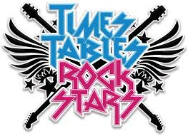
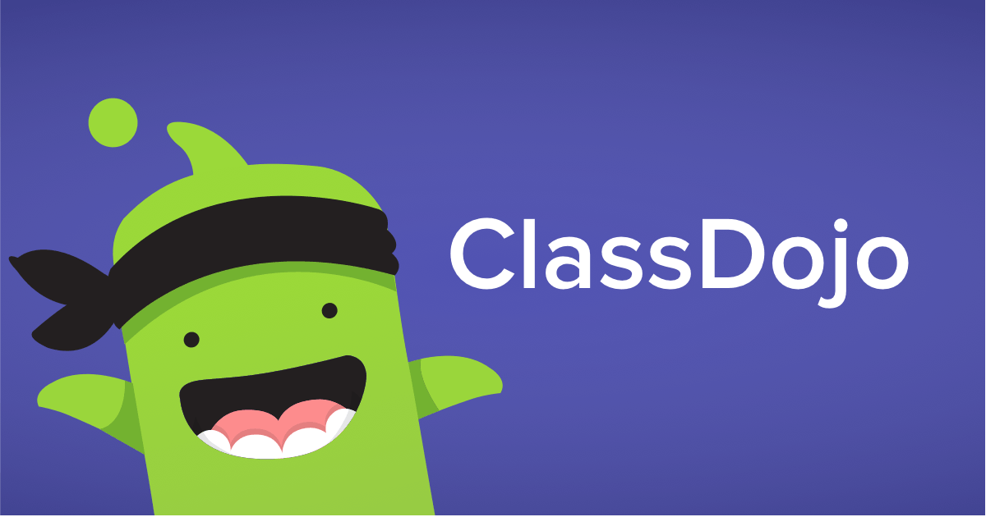
- Additional work on class page on the website or on Teams or Class Dojo
IN LINE WITH STATUTORY GUIDANCE FROM THE DEPARTMENT FOR EDUCATION

