

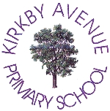
Dear

Parents/Carers,
Welcome back to the new school year! It has been lovely to welcome back old and new pupils and parents.
The children have settled well. The school is a happy place as we walk around the classrooms. We are all looking forward to an exciting year ahead. The start of any new academic year is always important for your children. There is always excitement and some apprehension about what their new teacher will be like and about what the expectations of the new year will be. As well as hard work and good effort, we are sure we will have a year that will be full of fun together.
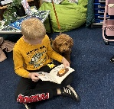

Some of the things we are most proud of last year are:
- School Games Mark – Gold Award for PE
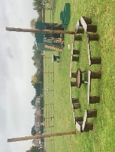
- Welcoming our fully trained therapy dog ‘Bennie’
- Our new Forest School area run by Mrs Davis and Mr Clifford (now fully trained)

- Our Ofsted Inspection and the praise for the whole school community
- Our Year 1 phonics results which have increased by 10% this year
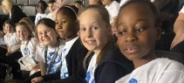
- Our KS2 SATs results that have increased in ‘Reading’, ‘Maths’ and ‘Grammar, Punctuation and Spelling’ as well as the combined Reading, Writing and Maths score
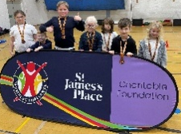
- All of our amazing children who have represented us over the year in music and sporting events, such as Young Voices and the SEND panathlons
- Our many musical and drama shows and concerts, more recently our instrumental concert and Year 6’s ‘Yee-Ha!’
- Our brilliant Year 6 students who have now left us and have undertaken the next stage of their education – we wish them the very best.
Important Dates
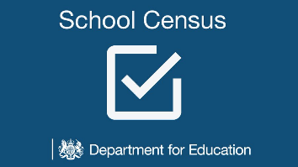
8th Oct Flu vaccines (Reception to Year 6)
9th Oct – School Census Day
10th Oct Hello Yellow day
14th Oct Y6 Parents’ meeting
13th-17th Oct Parent consultations (Nursery to Year 5)
16th Oct Maths Café
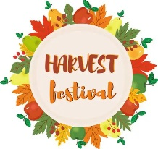
17th Oct Photographs
21st Oct Boggledy Books
22nd October – Non uniform day in exchange for Harvest Festival donations that will be sent to charity
23rd Oct Harvest (Y5 parents)
24th End of term – (School re-opens to all pupils on Monday 3rd November)

