Kirkby Avenue Primary School | School Office
Kirkby Avenue | Tel: 01302 782953
Bentley Road | admin@kirkbyavenueschool.co.uk
Doncaster    DN5 9TF  Dear families and friends,  It is lovely to see that the children are settled in their new classes. Our Nursery and Reception children have made a great start and are a wonderful addition to our school community – we are excited to see all they will achieve during their time with us!  Thank you for attending parent meetings for your child, we hope this has been useful. If you still would like to see your child’s teacher, please make an appointment.  We have had a busy half term with Career’s Week and Harvest Festival, The children have worked hard for 8 weeks and we all need a well-earned rest. | Head Teacher  Mrs C A Clifford
Kirkby Avenue Autumn Newsletter
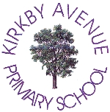


Panto
Key Stage 1 and Early Years classes really enjoyed the Panto!

Bryan, our published author
Lots of people bought Bryan’s book. He signed and put a message in them all!

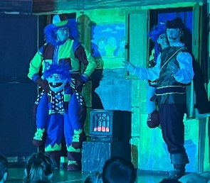
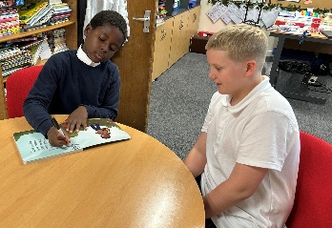
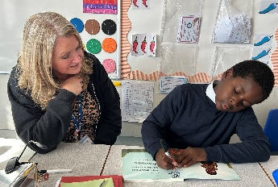
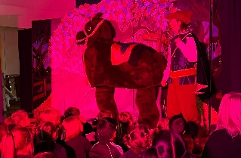

Career’s week
We were very lucky to have 15 visitors during Career’s week! These included nurses, a paramedic, a fire fighter, a pilot and workers from the beauty industry. It is important to encourage our pupils to work hard and to aim high!

Harvest
Thank you to all our families for donating to the Food Bank. Year 5 performed an excellent Harvest Festival and shared some amazing work! The food has been collected by the Trussel Trust to help local families in need.

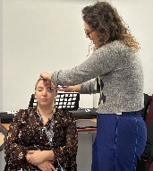

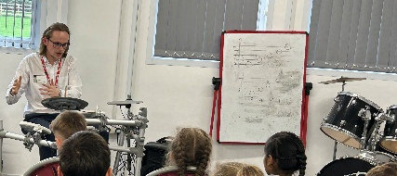
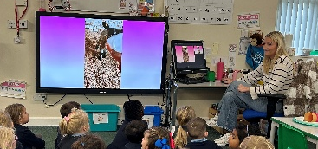

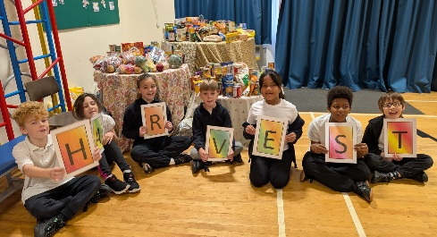

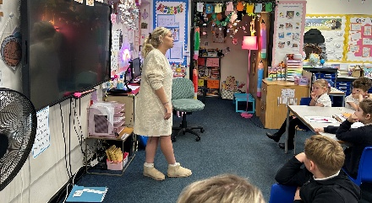
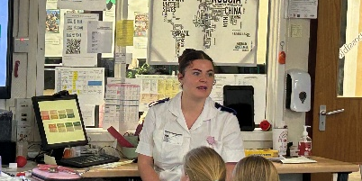




Attendance
Regular attendance is vital for children’s learning, development and social wellbeing. We celebrate good attendance in school with class and individual prizes.
 | Attendance last week | Attendance since September
Seedlings AM | 91% | 94.1%
Seedlings PM | 91.7% | 92.6%
Ash | 98.5% | 95.9%
Beech | 89.6% | 88.9%
Rowan | 97.2% | 94%
Holly | 95.8% | 94.4%
Cherry | 97% | 95.2%
Maple | 91.8% | 94.1%
Aspen | 99% | 93.1%
Willow | 93% | 95.5%
Larch | 93.3% | 92.9%
Chestnut | 95.9% | 96.9%
Oak | 92.4% | 95.4%

Well done to Chestnut, Ash, Cherry and Oak for great attendance this half term!



Seedlings: Jasmine
Ash class: Lola
Beech: Mehmet
Rowan: Olivia Mae
Holly: Dominic
Cherry: Emily
Maple class: Marnie.
Aspen: Elise
Willow: Evie
Larch: Neveah
Chestnut: Isabelle
Oak: Iasmina


Shining Stars







Key Dates for next half term
4th Nov – Flu vaccine catch-up
6th Nov – Boggledy Books
10th-14th Nov – Anti-Bullying week
11th Nov – Remembrance Day (wear a red top/tee-shirt for a donation)
19th Nov – Children in Need day (link to donate on Parent Pay)
24th Nov – Ash and Beech to Gullivers
1st-5th Dec – Christmas Crafts (Parents with Children)
2nd Dec – Y3 and Y4 to Cast Panto (those who have signed up already)
5th Dec – Y5 and Y6 to Cast Panto (those who have signed up already)
9th Dec – Early Years Xmas Performance am/KS1 Xmas Performance pm
10th Dec - Early Years Xmas Performance pm
11th Dec - KS1 Xmas Performance am
11th Dec – Xmas Fair (3.30-5pm)
12th Dec – KS2 Carol Concert
15th Dec – Y3 and Y4 Parties
16th Dec – Y5 and Y6 Parties
17th Dec – Early Years and KS1 Parties
17th Dec – Choir at Mount Hermon
18th Dec - Christmas Dinner and Christmas jumper day

Halloween Attendance Challenge
251 children achieved 100% attendance for the three weeks beginning 6th Oct-23rd Oct.
All children received a certificate, sweets and extra Dojo points.
The KS1/Early Years winner was Miles.
The KS2 winner was Theodore.
WELL DONE everyone!

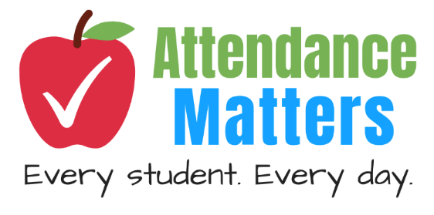



Have a lovely half term break, stay safe and we look forward to seeing you all back on Monday 3rd November.
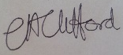
Mrs Clifford Head Teacher

